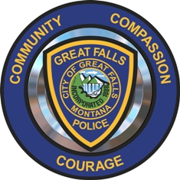
DDACTS Survey - Volunteer Guide

WHO: The GFPD volunteers’ primary goal is to survey the businesses within the DDACTS Zone. But, while out visiting businesses volunteers are encouraged to engage with community members and allow them to take the survey on the supplied tablet.

Participants must be at least 18 years old.

At a business we want to survey the owner, manager or a long term (2+ years) employee (in that order). A short term employee cannot take the survey on behalf of the business but can take it for themselves.

SURVEY: For individual that take the survey, we are giving away gift certificates, up to $150, to Downtown Great Falls. Participants must add their name to the survey and winners must have corresponding ID to pick-up their prize.

WHAT: The survey is intended to gauge the community’s feeling about their safety and the crime within the DDACTS Zone. We will be resurveying the respondents in about a year to see what has changed.

WHEN: The survey should only be conducted Mon thru Sat from 0900 to 1700.

WHERE: Any business within the DDACTS zone can be surveyed, as long as the volunteer team feels safe to do so. Park Drive to 15th St and 6th Ave N to 6th Ave S.

HOW:
- Via supplied tablet (no password, please plug tablet in at end of shift)
- Participants can complete the survey themselves or choose to have the volunteer ask them the questions and enter the answers for them
- Once a business has been visited the volunteers must log the visit to avoid duplication
- At the end of a shift please highlight the map with the area they visited

APPEARANCE: The goal is for the volunteers to look especially professional.
- Yellow and black jersey (white or black ls undershirt is ok)
- Nice jeans or pants
- Comfortable shoes
- Hats are fine as long as they do not endorse any political affiliation
- If outerwear is required please add a yellow traffic vest .

